**MODULE – 4 (A Logging using SLF4J)**

**Exercise 1: Logging Error Messages and Warning Levels**

**Task:** Write a Java application that demonstrates logging error messages and warning levels using SLF4J.

**1. Add SLF4J and Logback dependencies to your `pom.xml` file:**

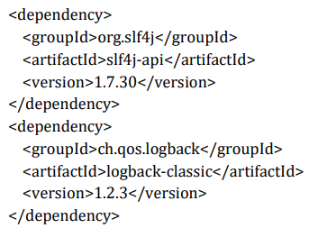

**2. Create a Java class that uses SLF4J for logging:**

**OUTPUT:**

